Noun Phrase as a Verb Complement?

✅ What Is a Noun Phrase as a Verb Complement?
# Source: AI Source: Provided by: [Data Path: Persons Table -> ID Column: 1, Name_En Column: Motasem Essam] -> From: [ChatGPT] on [8/4/2025]
A noun phrase functions as a verb complement when it follows a transitive verb and completes its meaning by identifying what or whom the action is directed toward.

🔸 Structure:
# Source: AI Source: Provided by: [Data Path: Persons Table -> ID Column: 1, Name_En Column: Motasem Essam] -> From: [ChatGPT] on [8/4/2025]
- A noun or noun phrase (may include determiners, adjectives, modifiers)
- Follows an action verb
- Answers "what?" or "whom?" after the verb

🔸 Examples:
# Source: AI Source: Provided by: [Data Path: Persons Table -> ID Column: 1, Name_En Column: Motasem Essam] -> From: [ChatGPT] on [8/4/2025]
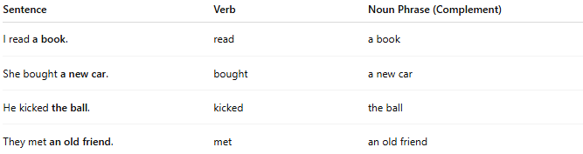
Sentence | Verb | Noun Phrase (Complement)
I read a book. | read | a book
She bought a new car. | bought | a new car
He kicked the ball. | kicked | the ball
They met an old friend. | met | an old friend

🔸 Why It's a Verb Complement:
# Source: AI Source: Provided by: [Data Path: Persons Table -> ID Column: 1, Name_En Column: Motasem Essam] -> From: [ChatGPT] on [8/4/2025]
Because the noun phrase is required to complete the meaning of the verb. Without it, the sentence is incomplete or unclear.
🟢 Example:
- ✅ "She bought a car." (complete)
- ❌ "She bought." (incomplete – missing complement)

